Kythnos 2008 Symposium on Microgrids
The Public Power Corporation (PPC) of Greece, the National Technical University of Athens (NTUA), and the Centre for Renewable Energy Sources (CRES) are pleased to organize and host the 4th in the series of Microgrid Symposiums on Kythnos Island on 2 June 2008.

Schedule of Events

Date | Time | Event
Thursday & Friday  29th & 30th May |  | PV-Hybrid and Mini-grid Conference, Glyfada, near Athens
Saturday  31st May 2008 | ferry times announced in May 2008 | free day  travel to Kythnos island from Pireaus or Lavrio (voyage time 1-2 hours depending on boat), accommodation in Loutra
Sunday 1st June 2008 | 10:00 – 13:00 | Technical Tour: Visit to the first European wind park (1982)/hybrid plant and the Gaidouromantra Microgrid site  transportation will be arranged by the organisers
Sunday 1st June 2008 | 13:30 – 18:00 | Lunch & Microgrid Book Stakeholder Meeting
Sunday 1st June 2008 | 18:30 – 20:30 | welcome by Kythnos local authorities, incl. a small workshop
Sunday 1st June 2008 | 20:30 | dinner at Kythnos Bay Hotel, Loutra, hosted by PPC
Monday 2nd June 2008 | 9:00 – 17:00 | Microgrid Symposium,*  at a Loutra Hotel
Monday 2nd June 2008 | 13:00 – 15:00 | lunch hosted by NTUA & CRES
Tuesday 3rd June 2008 | ferry times to be announced | return to mainland

*Symposium by invitation only, while the other events will be open to all
PV-Hybrid and Mini-Grid Conference participants
ACCOMMODATION IN LOUTRA, KYTHNOS

Loutra is situated in the northeast of the island, a 12 km bus or taxi ride from the port Merihas, where most ferry services arrive. It is the island's traditional hot springs resort, featuring warm sulphur spas, a hydrotherapy centre, plenty of tavernas, accommodation of all types, and a hotel with curative mineral baths. Symposium invitees are asked to arrange and cover their travel to and accommodation on Kythnos. Some recommended Loutra hotels are:

Hotel | Contact information | Rent
Kythnos Bay Hotel | tel.: +30 22810 31441 or 31218  fax : +30 22810 31444  http://www.kythnos-island.com/eng/services/hotels/kythnosbay/  or  http://www.vacation-cyclades.com/hotels/kythnos/kythnosbay/ | rooms for 60 €/night double occupancy, breakfast included
Porto Klaras Hotel | tel: +30 22810 31276 or 31600  fax : +30 22810 31355, or  +30 210 4836904  mobile: +30 6932 215777  http://www.porto-klaras.gr/ | rooms, studios and apartments, starting at 65 €/night.
Meltemi Hotel | tel.: + 30 22810 31271 or 31215  fax: +30 22810 31302  mobile: +30 6944760332  http://www.meltemihotel-kythnos.gr/ | single, double, or triple rooms, and apartments for 4-5 guests. starting at 60 €/night
THE CYCLADES ARCHIPELIGO

The Cyclades are a group of islands of varying sizes scattered over the deep blue waters of the Aegean Sea to the east of the Peloponnese Peninsula and south-east of the coast of Attica.

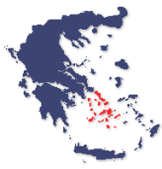

Greece

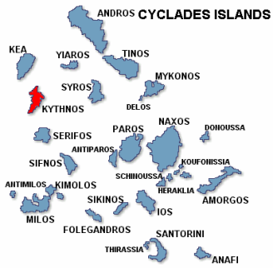

The Cyclades Group
KYTHNOS ISLAND

The island of Kythnos is located between Kea (Tzia) and Serifos, 100 km from Pireaus. Administratively, Kythnos belongs to the Kea province of the Cyclades Prefecture. Its area is about 100 km² and its circumference 58 km. The permanent population is about 1600 people, but during the summer tourist season the population may double. Residents are mainly employed in livestock and other agriculture, fishing, or tourism. The climate is dry with relatively cool summers favouring cultivation, but soils are poor. The island has good wind and solar potential. More information about the island can be found at http://www.kythnos-island.com/eng/.

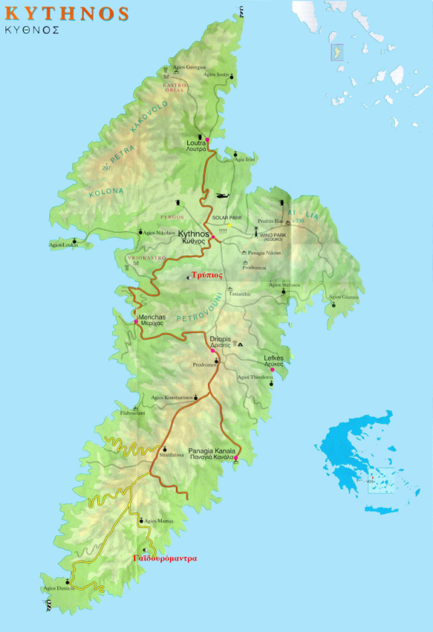
Gaidouromantra
TECHNICAL TOUR OF THE GAIDOUROMANTRA MICROGRID

The technical tour of the Gaidouromantra microgrid demonstation site near the southern tip of the island is planned for Sunday 1st June. Bus transportation will be provided.

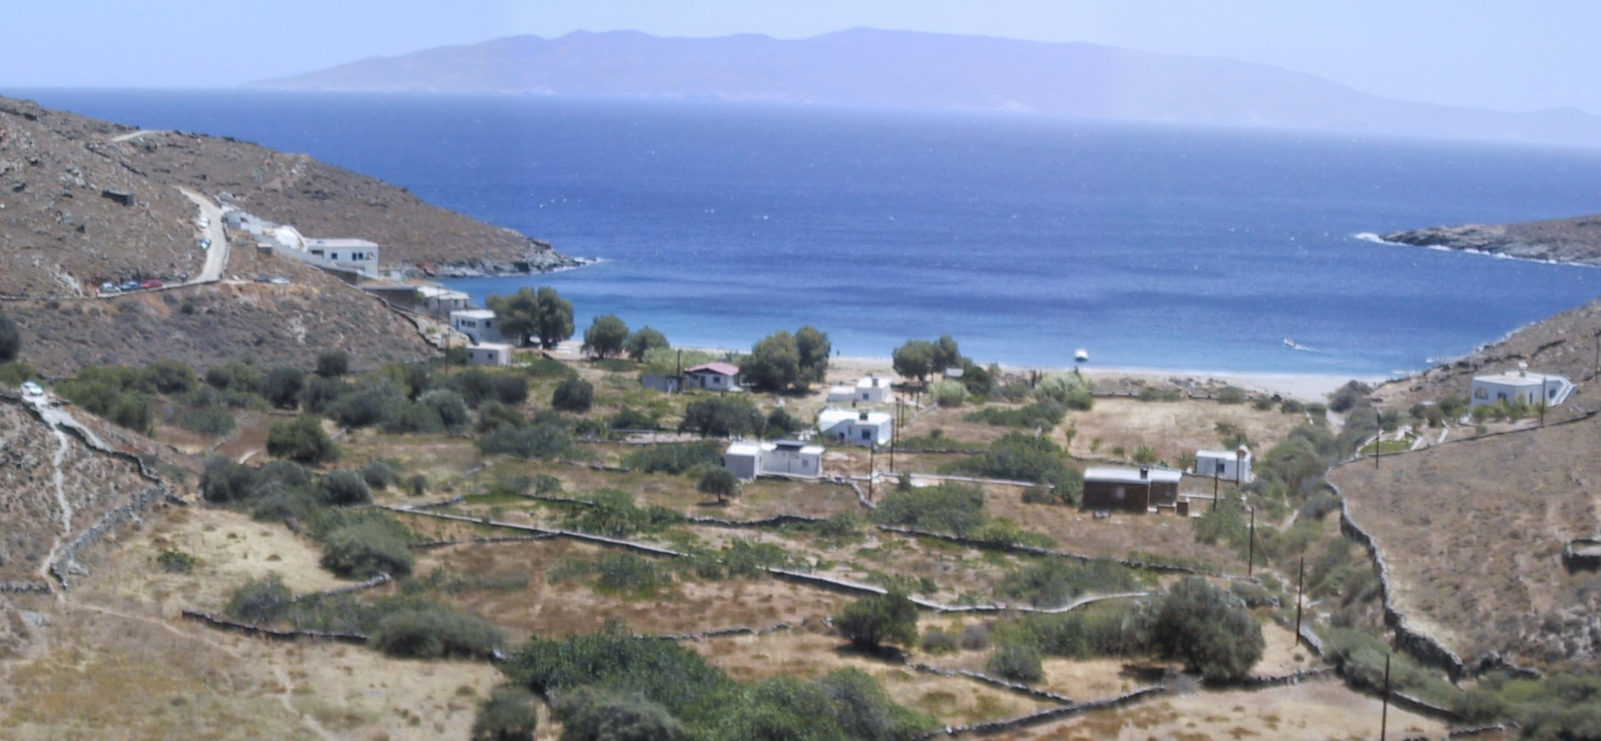
View of Gaidouromantra

This settlement is about 4 km from the closest medium voltage line. The grid and safety specifications for connections meet the technical standards of PPC, which is the local electricity utility, because eventually the microgrid may be linked to the island grid. The microgrid is 3-phase and composed of overhead power lines with parallel communications, serving 12 houses in a small valley. The peak power in each house is limited by a 6 A fuse. A 25 m² equipment shed was built in the middle of the settlement to house the battery banks and inverters, a diesel genset and its fuel tank, computer equipment for monitoring, and the communications hardware. The grid electrifying the homes is powered by 3 Sunny-island battery inverters synchronized to three-phase at 400V and 50Hz. Each battery inverter has a maximum power output of 5 kW. The battery inverters have the capability to operate in both isochronous or droop mode. Operating in frequency droop mode enables passage of information to switching load controllers when the battery charge is low and limits the output of the PV inverters when the battery bank is full. In the wider EU project More-Microgrids, local controllers were developed that fit into the house AC plugs facilitating control of individual loads using agents. Work is in progress to install a Microgrid Central Controller at the System House responsible for optimization of operations, or alternatively, to simply coordinate local controllers, which then assume primary responsibility for optimization. In the centralized approach, all necessary decisions are made by a central controller, while in the dispersed approach, agents negotiate though the communication link to arrive at solutions. Addition of a 5 kW 3-phase wind turbine is planned.

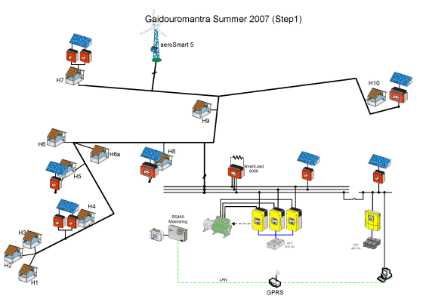
Phase 1 of Gaidouromantra Microgrid Modification

The current microgrid is composed of 10 kWp in multiple small PV arrays, a battery bank of a nominal 53 kWh capacity, and a diesel genset with a nameplate rating of 9 kVA. The PV modules are integrated as awnings into various houses. A second system provides power to the monitoring and communication equipment, and consists of about 2 kWp of PV mounted on the roof of the System House connected to a Sunny-island inverter and a nominal 32kWh battery bank. The installation of the grid and the systems was performed within two European Commission projects (PV-MODE, JOR3-CT98-0244 and MORE, JOR3CT98-0215). The current system upgrade is part of the European Commission’s More-Microgrids (http://microgrids.power.ece.ntua.gr/micro/index.php).

